Neon Juan

There can only be Juan

This is the official unofficial sort of design of neon Juan. Note it is suggested to change before the final product

Table of Contents

* Concept of Juan………………..3
* Flow of game…………………...4
* Enemies…………………………...6
* Bosses……………………………...9
* Stages……………………………...10
* Power-ups………………………..13
* Items………………………………..xx

**Concept of juan**

To describe Neon Juan we are looking for this concept

“*a guy in a bar tell this outrageous story*”

With this we can move forward with this as our basis. Neon Juan is a beat-em up game when you start off on a roof and fight enemies. With each platform is cleared you are moved to the next scene in which the floor collapse and you continue to the next level. There will be power ups and other things to help you on the way to defeat these enemies and bosses and also the final boss.

**Flow of game**

Here I will try to explain as much as possible what I think what we should go for

*Beginning*

1. 2. 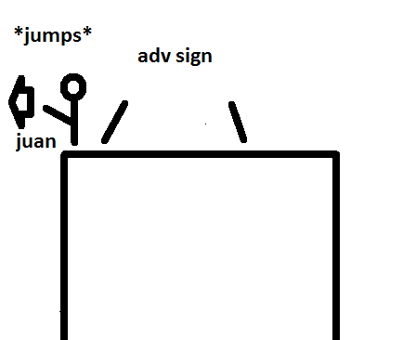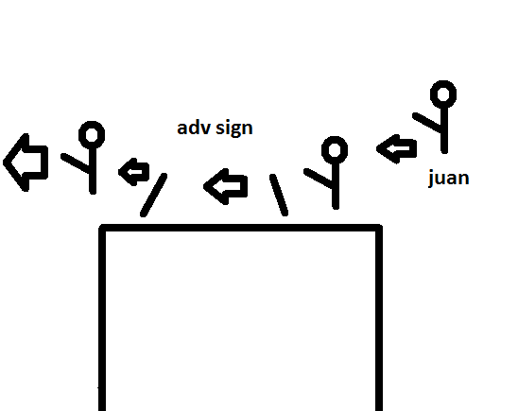

3. 4.

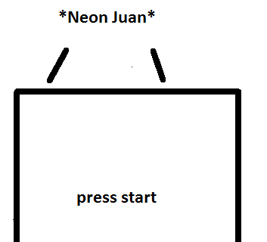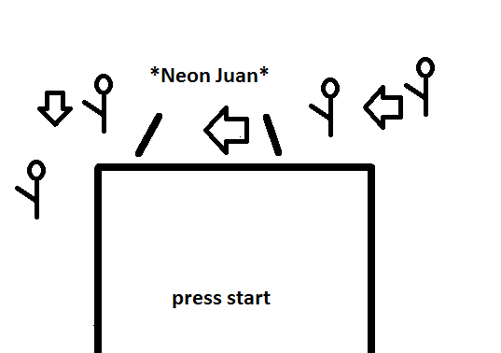

5.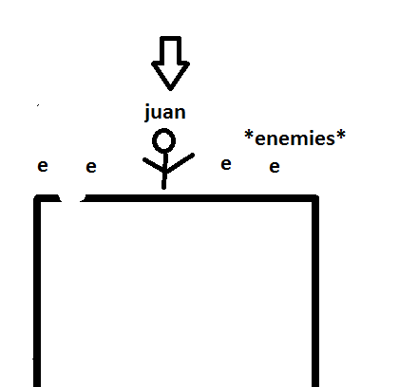

lets take the time to explain how the fights and game progresses.

As shown from 5 that you will start fighting on the roof against the first enemies once you defeat these enemies you go onto the next level by the ground breaking beneath him and you fall. This can be better shown in the next two horribly drawn art pictures.

Figure 1. Figure 2.

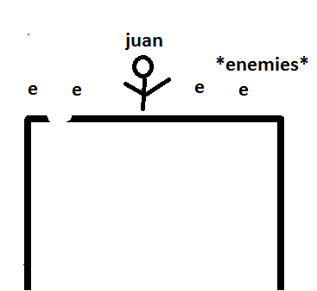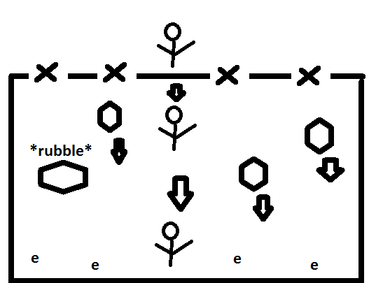

From the start of figure1 you can see juan fighting the enemies. Once he have fully killed all enemies the floor caves in and he falls as shown in figure 2. Maybe rubble from the ceiling may not but overall that is how he transfers to different levels.

There should be 5-10 levels of these before you fight the boss. With 7 bosses there should be a maximum of 70 levels.

**Enemies**

There will be one common enemy throughout the game, there will be a couple “transforming” enemy, and there will be special enemies.

Common enemy:

These enemies will be our constant people we fight against.

Neotech Nukes Gang

These are guys who basically just look like thugs but one appendage or body part are robotic.

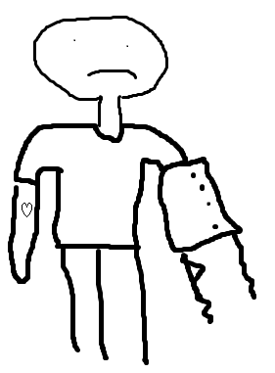

Then we have the “transforming” enemies

These are the enemies that the closer you get to the boss maybe two levels before that the enemies just start looking like the special enemies. For example which I would explain later the neotech nuke gang where bell pepper outfits.

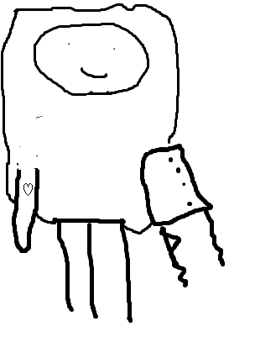

Then we have our special enemies which are the enemies you fight that have a very close reference to the boss you will be fighting such as lucha dores or robot skeletons.

Transforming Enemies

1. Chili outfits
   1. just the neotech nuke gang members in chili outfits
2. Neotech nuke gang with masks
   1. neotech nuke gang members with masks
3. Future police
   1. policemen but futuristic looking
4. Neotech nuke zombies
   1. Neotech nuke gang that are zombies
5. Neotech nuke band
   1. Neotech nuke gang that have instruments
6. Fully robotic Neotech Nuke gang
   1. all of the neotech nuke gang members body parts are robot
7. T.A.C.O security
   1. security guards that look like guards
8. neotech horrbiletech nuke gang
   1. robot parts of neotech nuke gang are old robot parts
9. cactus
10. a. animals that from the desert basically

Special Enemies

1. Chilis
2. Luchadores
3. Aztec police
4. Robot candy skeletons
5. Mariachi band
6. Neon juan bots
7. quartz desert animals
8. old robot minions
9. T.A.C.O executives

**Bosses**

What is a game without bosses. These Bosses are going to do a set pattern and give you a chance to hit them when they are stunned or taunting. The bosses are as followed;

1.Chip and Potle

2. Lucha dora the destroya

3. Aztec Chief-tan

4. Skeletron

5. Super Suave Santiago

6. NeonJuan2.0

7. Quartzalcoatl(quetzalcoatl)

8.BETAMAX

9.T.A.C.O B.O.S.S (things. against. crunchy. oppression. being. of. super.succulence)

**Stages**

There will be 9 different stages. Each stage will have 5-10 levels. Each stage you will start in a different building. Buildings with have their own theme each.

easy stages 5 levels (names suggested to change)

*Nice Spice*

enemies:neotech nuke gang, chili outfits, chili peppers

boss: chip and potle

level theme: food and catering.

*NNWF(neotech Nuke Wresteling federation)*

enemies: neotech nuke gang, neotech nuke gang with masks, luchadores

boss: luchadora the destroya

level theme: wrestling type, with practice rings, different martial arts

*Policia Azteca*

enemies: neotech nuke gang (prison outfits), future police, aztec police

boss: aztec chief-tan

level theme: police station

medium stages 7 levels

*Dead Sweets*

enemies:neotech nuke gang, zombie neotech nuke gang, robot candy skeleton

boss: skeletron

level theme: day of the dead, graveyards

*Santiago estudio de música*

enemies:neotech nuke gang, neotech nuke gang with instruments, miraichi band

boss: Super Suave Santiago

level theme: music studio

*1-800-ROBOTIZED*

enemies: neotech nuke gang, robot neotech nuke gang, juan bots

boss: neon juan 2.0

level theme: robot making factory

hard stages 10 levels

*Desert Museum*

enemies: neotech nuke gang, cactus, quartz sand animals

boss: quartzacoatl

level theme: desert

*antique an techs*

enemies: neotech nuke gang, neotech horrible tech nuke gang, old appliances (old robots)

boss: betamax

level theme: old tech stores, antique stores

*T.A.C.O Enterpises*

enemies: neotech nuke gang, security guards, T.A.C.O executives

Boss: T.A.C.O.B.O.S.S

level theme: Office building

Powerups

Powerups will be given at random intervals of the game to insure that the player will be able to win during certain levels of the game. Powerups will be dropped down from a flying Taco Truck Vender for the player to use. Powerups do not have to be used and can be saved for certain parts of the game. There will be three slots beside Juan’s icon that shows that a powerup has be stored.

To use a powerup the player will push the powerup button and use the first powerup that was stored. Also powerups can only be used one at a time for added difficulty. So the player can not use another powerup until that one is finished. Also players can only store three powerups

Hot Tamale: This powerup allows Juan to use flame base attacks for an added bonus in attack power. This power up only last for 10 seconds so the player must use this powerup wisely.

Burrito: This powerup allows Juan to take three hits before losing any health. Perfect for heavy hitting enemies. Juan will wearing a clock like burrito.

Churro: This power-up allows Juan to move faster than enemies for 10 seconds. This power-up is perfect when trying to move from big waves of enemies cornering the player from different parts of the arena.

Juan Skins